Experiment 4 : Develop a program to control the DC Motor with Arduino Board
Date : 26.08.2025
Aim:
To develop the program to control the DC Motor’s direction and speed using Arduino Board.
Components Required:
S.No | Components Name | Range/Rating | Quantity
1 | Universal Bread Board |  | 1
2 | Arduino Uno board |  | 1
3 | DC Motor |  | 1
4 | L293D H-bridge motor | L293D or L298N | 1
6 | Potentiometer (10kΩ) |  | 1
7 | Push Button (optional, for direction control) |  | 1
8 | 6V battery pack (for the motor) |  | 1
9 | USB Cable |  | 1
10 | Jumper Wires |  | required

Hardware Setup:
L293D or L298N: This is crucial as Arduino pins cannot directly supply enough current for a DC motor. The L293D has pins for motor inputs (connected to Arduino digital pins), enable pins (for speed control via PWM, connected to Arduino PWM pins), and power supply pins (VCC and GND).
Power Supply: Connect the motor driver's VCC to the Arduino's 5V or an external power source if needed for higher power motors, and GND to Arduino's GND.
Motor Connections: Connect the motor terminals to the output pins of the motor driver.
Control Pins: Connect the motor driver's input pins (e.g., IN1, IN2) to Arduino digital pins to control direction. Connect the enable pin (e.g., ENA) to an Arduino PWM pin for speed control.
.
Connecting setup
Place components: Start with an Arduino Uno, a breadboard, a DC motor, an L293D motor driver, and a 6V battery.
Connect power and ground rails:
- Connect the Arduino's 5V pin to the red positive (+) rail on the breadboard.
- Connect the Arduino's GND pin to the blue negative (-) rail on the breadboard.
- Connect the + terminal of the 6V battery to the positive rail.
- Connect the - terminal of the 6V battery to the negative rail.
Connect the L293D:
- Place the L293D IC so it straddles the center divider of the breadboard.
- Connect the L293D's VCC pin (pin 16) and Vs pin (pin 8) to the positive rail.
- Connect the L293D's GND pins (pins 4, 5, 12, and 13) to the negative rail.
Wire the motor:
- Connect one terminal of the DC motor to OUT1 (pin 3) on the L293D.
- Connect the other terminal of the DC motor to OUT2 (pin 6) on the L293D.
Connect Arduino control pins:
- Connect the Arduino's digital pin 9 to the L293D's IN1 pin (pin 2).
- Connect the Arduino's digital pin 10 to the L293D's IN2 pin (pin 7).
- Connect the Arduino's digital pin 11 to the L293D's Enable 1, 2 pin (pin 1). Using a PWM-capable pin (indicated by a "~") for the Enable pin allows for speed control.
Potentiometer: Used to adjust the motor speed.

Connection Diagram: -

Pin diagram of the L293D :
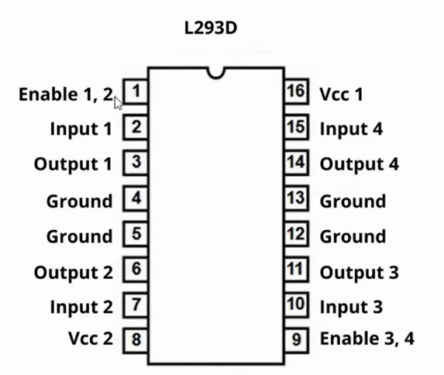

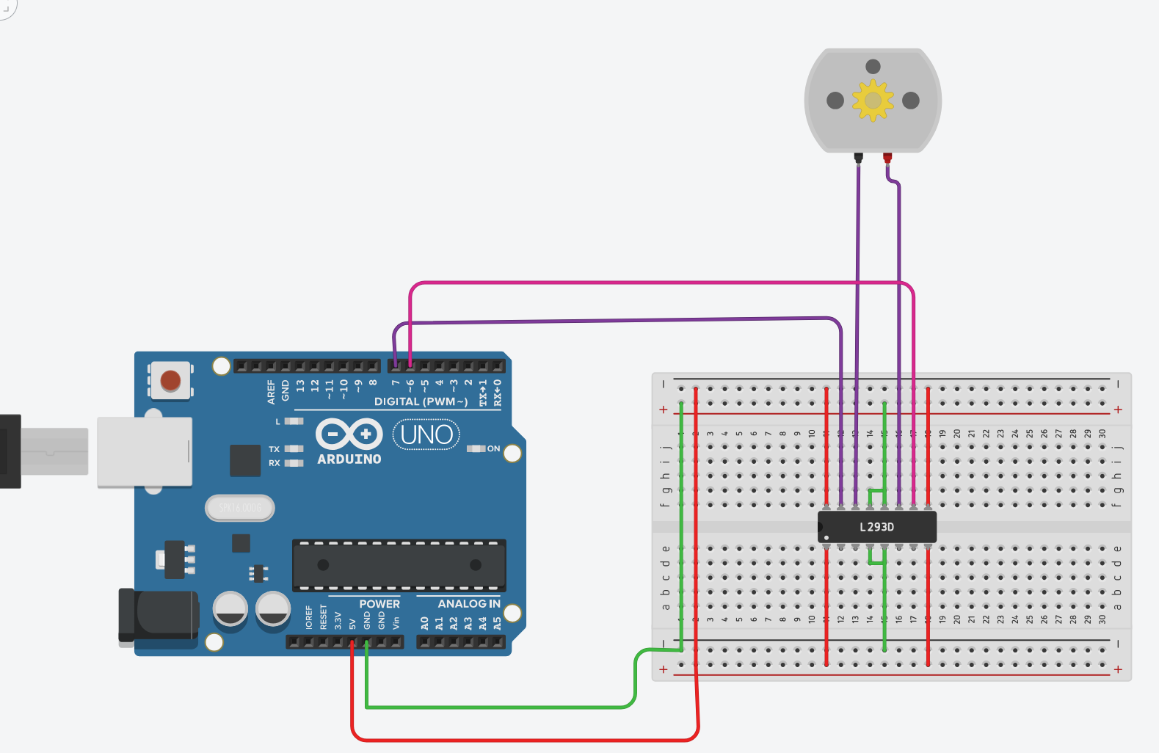
Program 2 (working program)
// C++ code
//
void setup()
{
pinMode(7, OUTPUT);
pinMode(6, OUTPUT);
}

void loop()
{
digitalWrite(7, LOW);
digitalWrite(6, HIGH);
delay(2000); // Wait for 2000 millisecond(s)
digitalWrite(7, HIGH);
digitalWrite(6, LOW);
delay(2000); // Wait for 2000 millisecond(s)
}

Working Observation:
- Adjust the potentiometer slider to change the motor speed. The motor should rotate faster or slower depending on the potentiometer setting.
- If you use the push button, pressing it should toggle the direction of the motor rotation. If you don’t use a button, you can set the direction in the code.
- Monitor the Serial Monitor to see the current motor speed and direction.

- motorPin1 and motorPin2: Control the direction by setting one HIGH and the other LOW.
- PWM Control: The analogWrite() function sends a PWM signal to the ENA pin, which controls the speed of the motor by varying the duty cycle
- enablePin: Controls the speed using analogWrite(), which sends a Pulse Width Modulation (PWM) signal. A value of 0 is off, and 255 is full speed.
- setup(): Configures the pins as outputs and initially sets the motor to off.
- loop(): Contains the logic to control the motor's direction and speed with delays for demonstration. You can modify this to integrate other inputs like buttons or potentiometers for interactive control.

RESULT: DC Motor Direction and speed control program is successfully implemented and executed with Arduino microcontroller Board.

